**Type of Model: Adherence Clubs**

**Name of Interviewee: Emson Masinine**

**Age: 32**

**Job Title: State Registered Nurse**

**Health Facility: Gutu Mission Hospital**

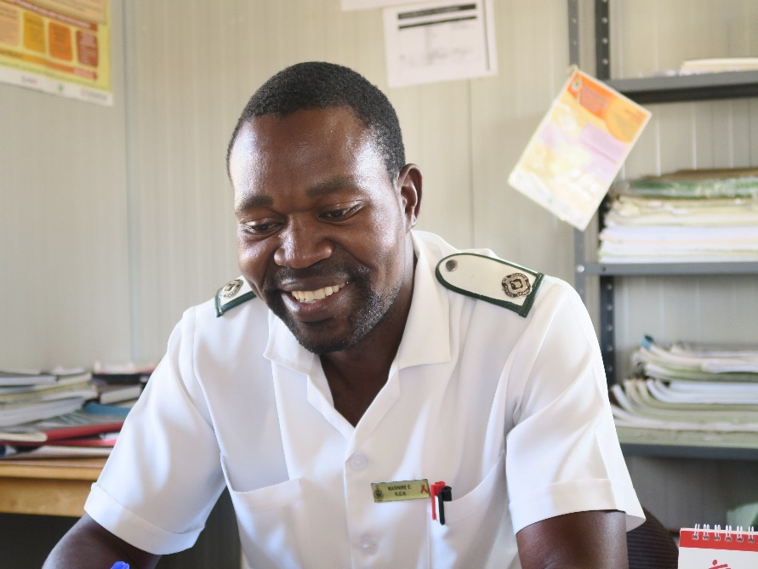

**The experience by our clients and the way we work at this hospital has greatly improved ever since Adherence Clubs were introduced at Gutu Mission Hospital, says Nurse Emson Masine who is also part of the team managing the clubs at the hospital**

I have been part of the team implementing the Adherence Clubs model of care at Gutu Mission Hospital since their introduction in 2017, and I can attest to the fact that the experience by our clients and the way we work at this hospital has greatly improved because of this system. It was quite hard in the beginning; there was a lot of setting up of systems and processes that we needed to do initially such as placing people into groups, and it felt like it was unnecessary and time-consuming. We started realizing the benefits of all of that, and our work has become much easier.

We attend to clients much faster, less than 30 minutes. We also encourage people to remain behind after collecting their medication for a health education session, although this is affected by some people not willing to attend, or missing their appointment due to migration, work and now COVID-19 restrictions. However, we still educate the ones able to attend on drug side effects, resistance and management as well as mental health and their general well-being. We have managed to increase the clubs to 44, each having between 10-30 individuals. We have also seen many males joining the clubs, which is very encouraging; men usually default because they are not patient or are busy to wait in the queues or spend lengthy periods waiting before being attended to.

Because the visits by club members are scheduled, we prepack their medication such that most of the work with adherence clubs is complete my mid-morning, leaving the rest of the day to attend to other areas of our work.

We are very grateful to Ministry of Health management; they have allowed us to integrate adherence clubs in our work and allowed us to attend training sessions and other technical activities offered by MSF. Without management support, the programme would not have succeeded. Besides managing the clubs, I have also acquired other skills such as mentoring, facilitation and counselling and this has enhanced my skills, confidence and effectiveness in my work.

Besides the difficulty of setting up, my experience is that adherence clubs are easy and cost effective to set up. They are sustainable, as they do not require many resources to set up. We even have a delivery manual that we use to systematically set up the clubs.

Given the support by MoHCC and how the clubs have helped the hospital to become more efficient, I am certain that adherence clubs will continue for years to come.